**Class Exercise #1: IP Address Class Identification**

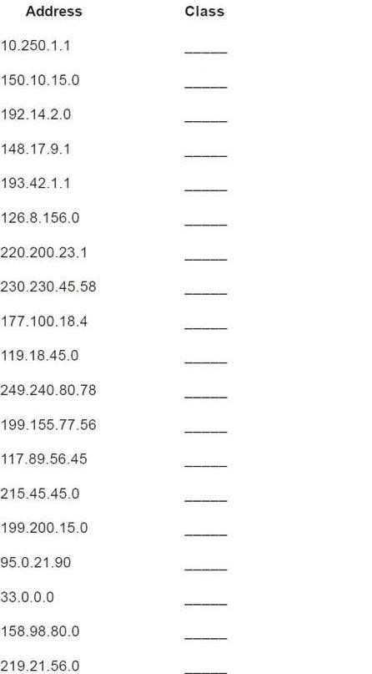

C

B

A

A

C

C

A

C

E

A

B

D

C

A

C

B

C

B

A

**Class Exercise #2: Network & Host Identification**

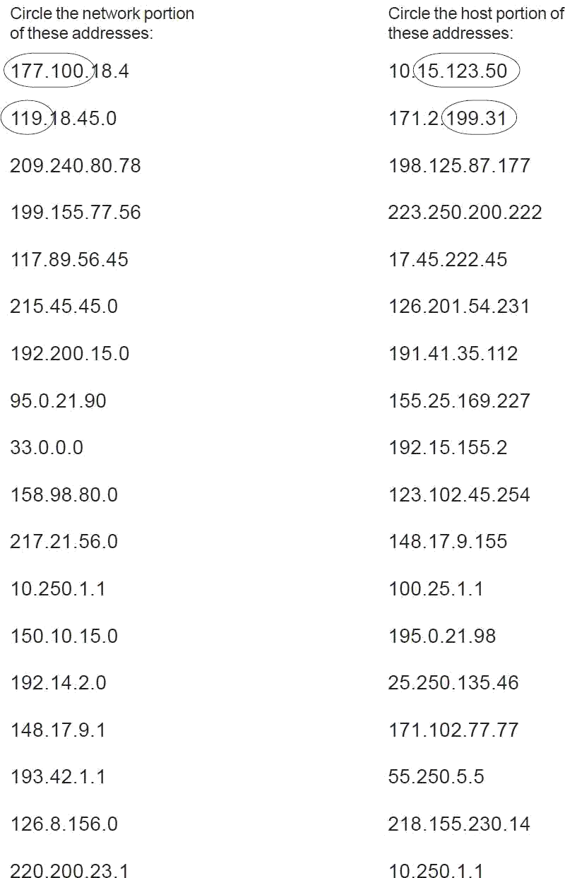

**Class Exercise #3: Network Addresses Identification**

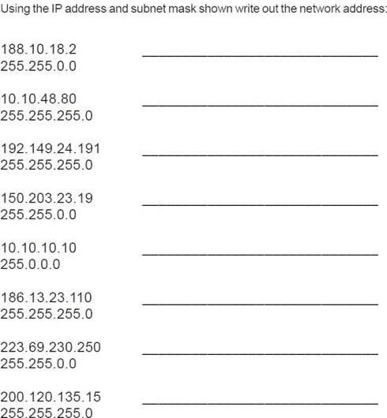

200.120.135.0

223.69.0.0

186.13.23.0

10.0.0.0

150.203.0.0

192.149.24.0

10.10.48.0

188.10.0.0

**Class Exercise #4: Host Addresses Identification**

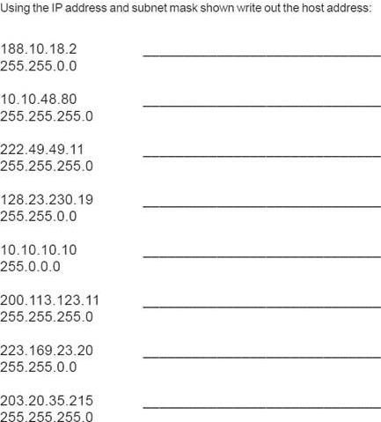

0.0.0.215

0.0.23.20

0.0.0.11

0.10.10.10

0.0.230.19

0.0.0.11

0.0.0.80

0.0.18.2

**Class Exercise #5: Default Subnet Masks Identification**

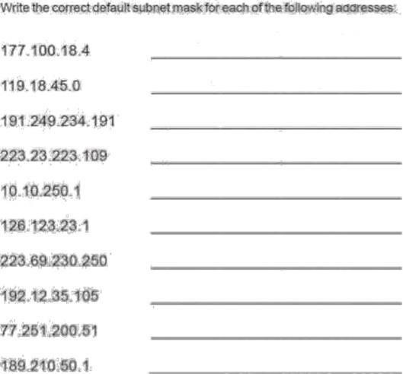

255.255.0.0

255.0.0.0

255.255.255.0

255.255.255.0

255.0.0.0

255.0.0.0

255.255.255.0

255.255.0.0

255.0.0.0

255.255.0.0